Layout guide for International Journal ICMAHEA using Microsoft Word (Times, 16pt, Bold)

S. Rahayu^{1,*} and M. Saleh^{1,2} (Times, 12pt, Bold)
¹Graduate of Chemical Engineering, Universitas Muhammadiyah Palembang, Jalan A. Yani 13 Ulu Palembang, 30251, Indonesia (Times, 12pt)
²Graduate of Management, Universitas Muhammadiyah Palembang, Jalan A. Yani 13 Ulu Palembang, 30251, Indonesiav(Times, 12pt)

*Corresponding author: jrmtp@um-palembang.ac.id (Times, 12pt)

Abstract. Abstract title is written with Times News Roman style (10 pt and bold) and centered format. The body text of abstract is written in italic style (10 pt) amounts 150-200 words, with left margin and right margin 25 mm and 20 mm from edge. The abstract should be clear, concise, and descriptive. This abstract should provide a brief introduction to the problem (preferably 1-2 sentences, objective of paper, research method in short, and a brief summary of results. The abstract should end with a comment on the significance of the results or a brief conclusion. The abstract is preferably not more than 300 words. Keywords written under the abstract text are arranged in alphabetical order and separated by a semicolon. Title keywords are written with regular format with 10 pt bold font while the key words in italics (italic)with MLSS concentration 3.4mg/L, aerator flow rate 1.2 ml/min, pH 7.36, and HRT 248.56 min. (Times , 10 pt)

Keywords: abstract; keyword; tittle; writing guidelines (Times , 10 pt)

(Received : xx xx xxxx; Accepted: xx xx xxxx; Published: xx xx xxxx)

INTRODUCTION
Articles should be written in times new roman, 10 pt, on A4 paper (210 x 297 mm) two-column format (i.e., 85 mm each) with a 2.5 cm margin at the top, a 2.5 cm margin at the bottom, 2.5 cm margin on the left, and 2 cm margin on the right. The beginning of the paragraph is written indented by a distance of 1 cm. The maximum number of article pages is 10 (including pictures and tables) and written justified. Lines are one-half spaced, justified. Page numbers should be included in the text located in footer section of each page. Use of pronouns such as I, we etc is to be avoided. Articles are written without page numbers and arranged in the following order: Title, Abstract, Keywords, Introduction, Research Method (or Model Development), Results and Discussion, Conclusions, Acknowledgments (if any), Notation List (if any) and References. Articles submitted must be free from plagiarism and autoplagiarsm.
Articles should be written in English. They can be results of research, state of the art studies, and analysis and problem solving in industries relevant to the field of chemical engineering, which have not been published in other publications. Introduction could be written max 1.5 pages.

METHOD
General Instructions
This section contains the method that should be explained naratively and also illustrated in flow diagram that was showed the steps of method. For the purposes of clarity and systematic writing, subtitles can be made in this section. Writing the manuscript is required to use all the complementary tools.
More Instructions
More instructions are written in bold with Capital Each Word format and arranged align left with no number and underscore. More instructions explain about the detailed instructions in the research.

RESULTS AND DISCUSSION
Figures and Tables
This section contains the results of data analysis (in the form of tables or figures, not raw data, and not the printscreen analysis results), the link between results and basic concepts and or hypotheses (if any), and the compatibility or conflict with results of previous studies. This section can also contain implications of both theoretical and applied research results. Each image and table must be referred to in the text.
For the purposes of clarity and systematic writing, subtitles can be made in this section. Writing the manuscript is required to use all the complementary tools (such as illustrations, photographic images, tables and graphics). In the results and discussion, it does not contain writing in the form of answers (read: chapter chapters) such as thesis writing or technical reports.
Figures and Tables are placed in groups of text and annotated. The figure should be followed by the caption which placed under the figure and the table followed by the caption placed on the table. The figures and the tables are numbered. The figure is guaranteed to be printed clearly even though it is reduced to 50%. Figure is not framed. For colorful images or graphics, please send as many as 300 sheets if you want to print in color. Tables with no vertical lines, whereas horizontal lines are only shown in 3 main horizontal lines i.e. 2 horizontal lines for the column headings and 1 closing line for the bottom row.

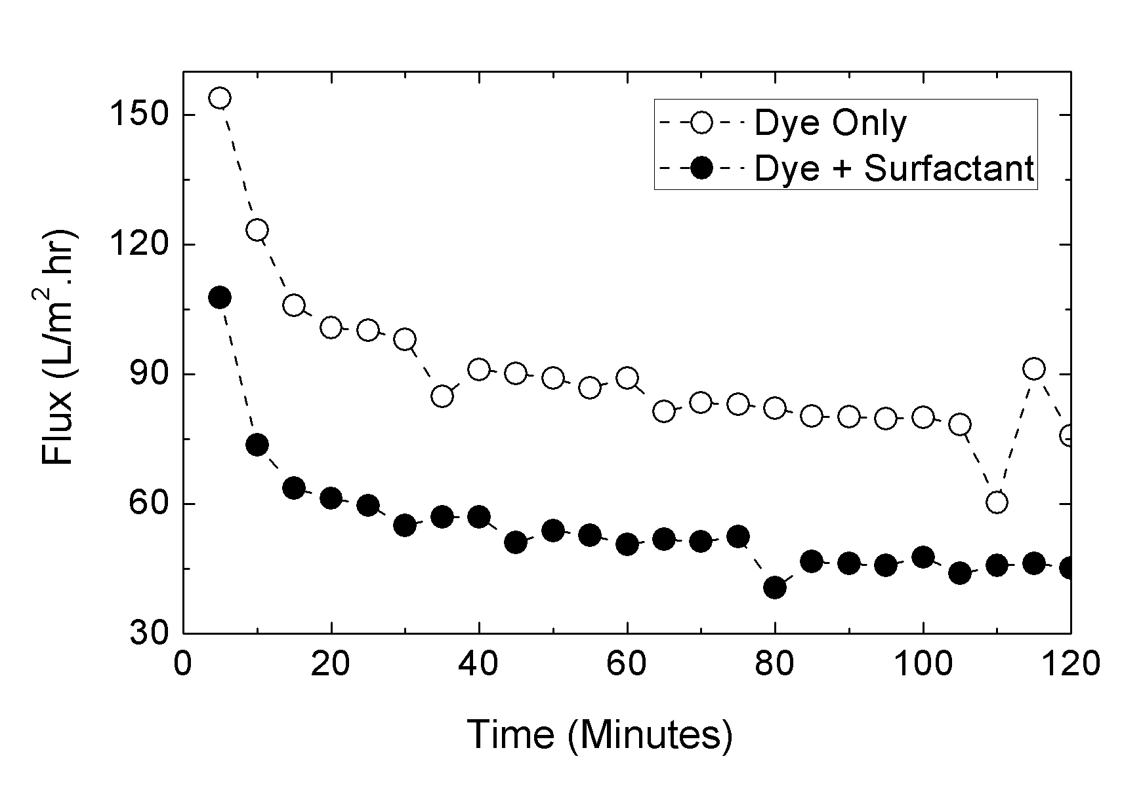

Figure 1. Flux Profile of Dye and Mixture of Dye and Surfactant Ultrafiltration at Remazol Blue concentration of 90 mg/l

Table 1. The microalgae composition of the Tetraselmis chuii species
Component | Composition (%w/w)
α-sellulose | 47.2 %
Hemisellulose | 35.5%
HWS | 17%

Equations
The equations are written center and numbered in parentheses. The number is placed at the end of the right margin of the column.
$D=\frac{A}{{\left(V_{rel}^{2}ρ_{a}\right)}^{2}}+B{\left(\frac{M_{air}}{M_{liq}}\right)}^{-β}$ (1)

Quote Writing
The writing system quotes a manuscript or literature use the Harvard system. The literature source is composed only of the author's name and the year of its publication. Examples: Attempts to search for better heat storage systems have been widely used, including the latent heat melting of PCM (Yanadoro and Matsuda, 2006 for one or two authors; Smith et al., 2011 for more than two authors). According to (2010), ………etc.

CONCLUSIONS
Conclusions should be written in paragraph for answer of each goal that described in introduction. Please do not use pointer or bullets and explain the conclusion one by one in paragraph. Finally, close this section with closing statements that show the significant result in this research.
The submitted articles will be reviewed by the Editorial Board and/or Reviewers. Correspondence will be addressed to the corresponding author. The author should immediately improve the article according to the reviewer's instructions. If the article has been declared acceptable, either the Main Revision or Minor Revision, the Author must correct it no later than 15 days after the notice. If the author does not improve his article more than 15 days, then when submitting the article will be considered as a new registration (New Submission).
The editor reserves the right to reject articles submitted if irrelevant to the field of social science, education, engineering, natural science or not up to date, have been published in other scientific magazines.

NOTATION
Notation is written alphabetically. Latin letters are written first, followed by an Arabic letter.

ACKNOWLEDGEMENT
The authors would thank to Graduate Program of Universitas Muhammadiyah Palembang for providing the facilities.

REFERENCES
References are listed alphabetically without numbering and the distance between the bibliography is 1 space (10 pt). The rules of writing used are as follows:
Magazine/scientific journal/proceedings:
Sumin, L., Youguang, M.A., Chunying, Z., Shuhua, S., and Qing, H.E., (2009), The Effect of Hydrophobic Modification of Zeolites on CO₂ Absorption Enhancement, Chinese Journal of Chemical Engineering, 17(1), pp. 36-41.
Book :
Fogler, H.S., (2006), Elements of Chemical Reaction Engineering, 4th, Prentice Hall International, Upper Sadle River, New Jersey, pp. 47-93
Disertation/thesis :
Djaeni, M., (2008), Energy Efficient Multistage Zeolite Drying for Heat Sensitive Products, PhD Thesis, Wageningen University, The Netherlands.
Patent :
van Reis, R.D., (2006), Charged Filtration Membranes and Uses Therefore, US Patent 7,001,550.
HandBook:
Knothe, G., van Gerpen, J., and Krahl, J., (2005), The Biodiesel Hanbook, AOCS Press, Campaign, Illionis, USA, pp. 70-84
Mujumdar, A.S. and Hasan, M., (2006), Drying of Polymers in Handbook of Industrial Drying, editor A.S. Mujumdar, 3rd ed, Marcel Dekker, New York, pp. 954-978.

